**Analysis of Algorithm**

**Project Proposal**

30 November 2020

**Ellis Mapakama & Lay Acheadeth**

**Project Idea.**

We plan to make a Program that will evaluate a maze from an image file and then use the shortest path algorithm to solve the route through which to go through the maze.

**Scope of The Project**

Be able to generate a Maze from an image file and read the maze.

Create a graph from the possible moves that can be taken through the maze

Evaluate the graph using the shortest path algorithms

Come up with the shortest route to the finish line of the maze

Show a finished maze with the possible route

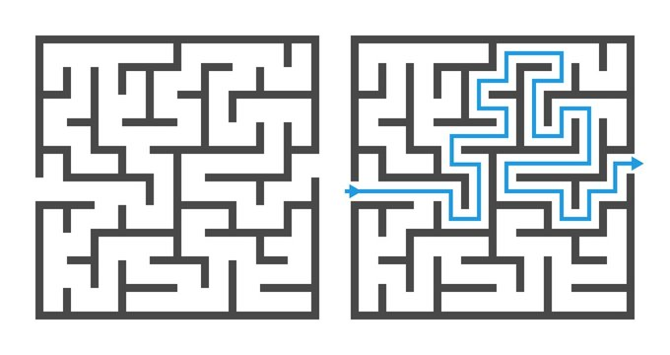

**Algorithms to be used:**

There are many algorithms that can be used to find shortest path but for this project we will analyze only two of the most common algorithms, which are Dijkstra’s algorithm and A* Algorithm.

After solving the maze we should be able to compare the runtimes of both algorithms over the same maze and conclude which one was the most efficient and how long it takes to complete the maze.

**Project timeline**

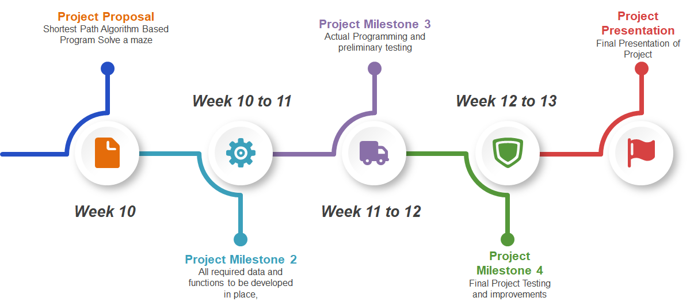

**Conclusion**

This Program seeks to demonstrate how the A* Algorithm and Dijkstra’s Algorithm works and that they can be used to solve complex problems in a short period of time.

It is also our hope that we will be able to show which one is efficient in doing the task